Smart Mobility under the Smart City Environment
Abstract
Quality of life is an important indicator for smart city development. To achieve a low-carbon economy, with the effort to increase renewables significantly, electric vehicles (EV) becomes the main type of transportation in cities. For example, the electric vehicle market in China has attracted about 18 billion dollars capital. However, huge integration of EVs will pose great challenges to the electricity distribution network stability and efficiency of the transportation systems. This keynote presents methods for charging station site selection, charging schedule scheme and reviews requirements for batteries. Some real-world examples will be given.
Speaker Bio:
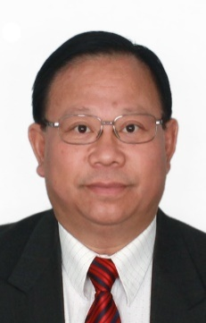

Professor Loi Lei Lai received Bachelor of Science with First Class Honours in 1980, Doctor of Philosophy in 1984 and Doctor of Science in 2005 from University of Aston, UK and City, University of London, UK, respectively, all in Electrical and Electronic Engineering. Presently he is University Distinguished Professor at Guangdong University of Technology, China; an Honorary Graduate of City, University of London, UK; IEEE Systems, Man, and Cybernetics Society (SMCS) Standards Committee Chair; Intelligent Power and Energy Systems Technical Committee Chair; IEEE Smart City Publications Committee Chair; the 2020 IEEE International Conference on Smart Cities Technical Programme Committee Co-chair. He was Director of Research and Development Centre, State Grid Energy Research Institute, China; Vice President for IEEE Systems, Man, and Cybernetics Society (IEEE/SMCS); Professor & Chair in Electrical Engineering at City, University of London; and a Fellow Committee Evaluator for IEEE Industrial Electronics Society. He was awarded an IEEE Third Millennium Award in 2000; the IEEE Power and Energy Society (IEEE/PES) United Kingdom and Republic of Ireland Power Chapter Outstanding Engineer Award in 2000; IEEE/PES Energy Development and Power Generation Committee Prize Paper in 2006 & 2009; and IEEE/SMCS Most Active Technical Committee Award in 2016. He is a Fellow of IET and IEEE. His current research areas are in smart cities and smart grid.

